**AIM OF THE PROJECT :** Micro-Project to find Factorial of a Number in 8086 microprocessor using assembly language programming

**Brief Description :**

* 8086 Microprocessor Is A 16-Bit Microprocessor Having 20 Address Lines And16 Data Lines That Provides Up To 1MB Storage.
* It Consists Of Powerful Instruction Set, Which Provides Operations Like Multiplication And Division Easily.
* In [Computer Programming](https://en.wikipedia.org/wiki/Computer_programming), Assembly Language Is Any [Low-Level Programming Language](https://en.wikipedia.org/wiki/Low-level_programming_language) In Which There Is A Very Strong Correspondence Between The Instructions In The Language And The [Architecture's](https://en.wikipedia.org/wiki/Computer_architecture) [Machine Code](https://en.wikipedia.org/wiki/Machine_code) [Instructions](https://en.wikipedia.org/wiki/Instruction_set_architecture).
* The Different Components Of Assembly Language Program Are Editor, Assembler, Linker And Debugger
* In The Project Different Registers Such As Accumulator (Ax) And Counter Loop(Cx) Are Used.
* The Project Consist Of Different Instruction Such As Jnz (Conditional Jump), Mov (Move), Cmp (Compare)
* The Project Also Consist Of Different Assembler Directives Such As Data Segment, Code Segment,Assume,End,Etc
* The Result I.E The Factorial Of Respective Number Is Stored In The Ax Register which is also known as accumulator.

**Aim of micro project :**

This micro project aims at:

* To find factorial of number using assembly language programming
* To make use of different register in assembly language programming
* To understand the use of different assembler directives of 8086 microprocessor
* To understand the use of different instruction in 8086 microprocessor.

**Course Outcome integrated :**

* Write assembly language program for given problem
* Use instruction for different addressing modes
* Develop assembly language program using assemble

**Actual procedure followed :**

1. **Group Formation:-** MIC is a subjects which helps us to learn about different instructions of 8086 microprocessor for development of different assembly language program.The basic aim of micro- project is to accelerate the attainment of the variouse outcome in the course.In the first 2 weeks of December the subject was introduced to us .The syllabus as well as details of micro-project was discussed.The group of 3 memebers were formed and the group leaders were selected.The schedule of Plan “A”,”B”& “PRESENTATION” were finalized.The variouse micro-project topics related to subject was discussed our guide gave us the opportunity to select the topic of our choice.
2. **Finalization Of Micro-Project:-** After attending the lectures for 2 weeks.We selected the topic for micro-project.We discussed the topic with our Guide regarding the concept which we are going to apply in the project.We individually tried to explain the basic platform of project.
3. **Planning:-** After finalization of the project we started working on the project.we started the planning phase.We discussed among ourselves regarding the resources such as hardware & software requirements such as assembler,editor,linker,debugger .In this week we completed ‘PART A PLAN’ of the micro-project which is nothing but a initial description about the project.We submitted it to the guide.
4. **Module Distribution &Analysis Part:-** Once the planning was over regarding resources,etc.We finalized the module (part) of project which we will be developing According to members we distributed the module among us We started the analysis of project.
5. **Design Part :-** In this part we created algorithm & flowchart for our micro-project .By doing this our queries related to project got cleared. With the help of this we were able to explain the guide how our project will actually work.
6. **Implementation :-** In the week we actually started the technical phase .In this phase we technically applied the algorithm & flowchart for each module.The coding for each module was done each member was writing code according to module assighned to them.
7. **Presentation :-** In this week we have to present the micro-project in front of the guide.Each member of group presented their own parts with confidence in front of guide.She asked us variouse queries regarding the topics.We presented the details of each concept of assembly language programming that we used in the project.She asked us to do variouse changes regarding some topics.
8. **Submission:-** This week was submission week.We submitted our project along with ‘Part A & B Plan’ to the guide.We also submitted the hard copies and soft copies of project to the guide

**Actual resources used :**

|  |  |  |  |  |
| --- | --- | --- | --- | --- |
| SR NO | NAME OF RESOURCES USED | SPECIFICATION | QUANTITY | REMARKS |
| 1 | COMPUTER | **PROCESSOR**-AMD  **HARD DISK-**2 TB  **RAM**-16GB  **OPERATING SYSTEM**-WINDOWS 10 PRO | 1  1  1  1 | HARDWARE & SOFTWARE USED |
| 2 | TASM |  |  | EDITOR,ASSEMBLER,LINKER,DEBUGGER  FOR ASSEMBLY LANGUAGE PROGRAMMING |
| 3 | PROGRAMMING LANGUAGE | ASSEMBLY LANGUAGE PROGRAMMING |  | PROGRAMMING LANGUAGE |

**Output of the micro project :**

The output of the project is according to following index :

|  |  |
| --- | --- |
| SR NO | CONTENT |
| 1 | ALGORITHM |
| 2 | FLOWCHART |
| 3 | CODING |
| 4 | CODE OUTPUT |
| 5 | REFERENCES |

FLOW CHART

**Start**

**d**

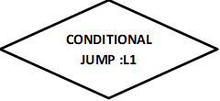

**END**

TRUE

**L1**

**DECEREMENT A/DATA**

**MULTIPLY A**

**CL🡨A**

**COMPARE CL,01**

**AX🡨DATA**

**DS🡨AX**

**AH🡨00**

**AL🡨A**

**Initialization of Data Segment (A db 5)**

ALGORITHM

* START
* Initialize data segment
* Move the data into ax register that is the accumulator
* Move AX into data segment
* Assign the MSB of AX register that is AH as 00
* Move data into lsb of AX register that is in AL
* Declare a loop L1 And in that put Instructions
  + - * DEC A < Decrement Data >
      * MUL A < Multiply Data >
      * MOV CL,A < Move A into Lsb of Cx >
      * CMP CL,01 < Compare Cl with 01 >
* Repeat the loop until the condition becomes false
* End

CODING

DATA SEGMENT

A DB 5

DATA ENDS

CODE SEGMENT

ASSUME DS:DATA,CS:CODE

START:

MOV AX,DATA

MOV DS,AX

MOV AH,00

MOV AL,A

L1:

DEC A

MUL A

MOV CL,A

CMP CL,01

JNZ L1

INT 21H

CODE ENDS

END START

CODE OUTPUT

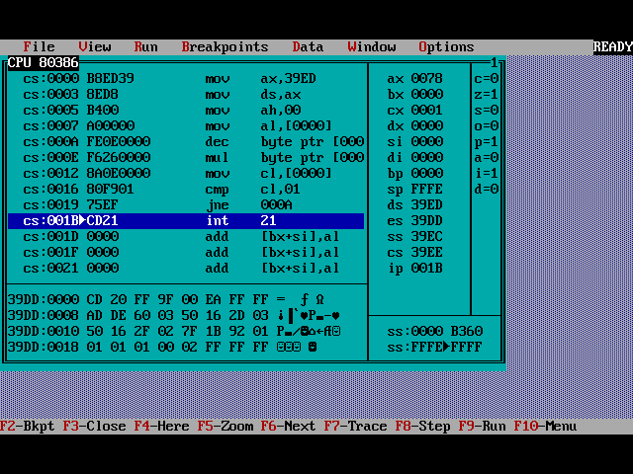

RESULT

REFERENCES

We do have used a few references during the process of building our project. The references used are from Websites, Books etc.

The references used are:

WEBSITES:

1: www.techsource.com

2: www.tutorialspoint.com.

3: www.quora.com

REFERENCE BOOKS:

1: “Microprocessor and Interfacing” by Douglas v

2: “The 8086 Microprocessor” by Tribel,Walter A,Singh Avtar

3:”Microprocessor and Microcontrollers” by Latha,Murugheshwari

**Skill developed/learning out of this micro project :**

* Since we worked in a group,We developed the skill of ‘TEAMWORK’ in us
* We came to know how and when to use some of the important concept of Assembly language programming
* We attained the satisfied level of programming